**Landing Page**

* UFO Icon takes you back home from anywhere on the page

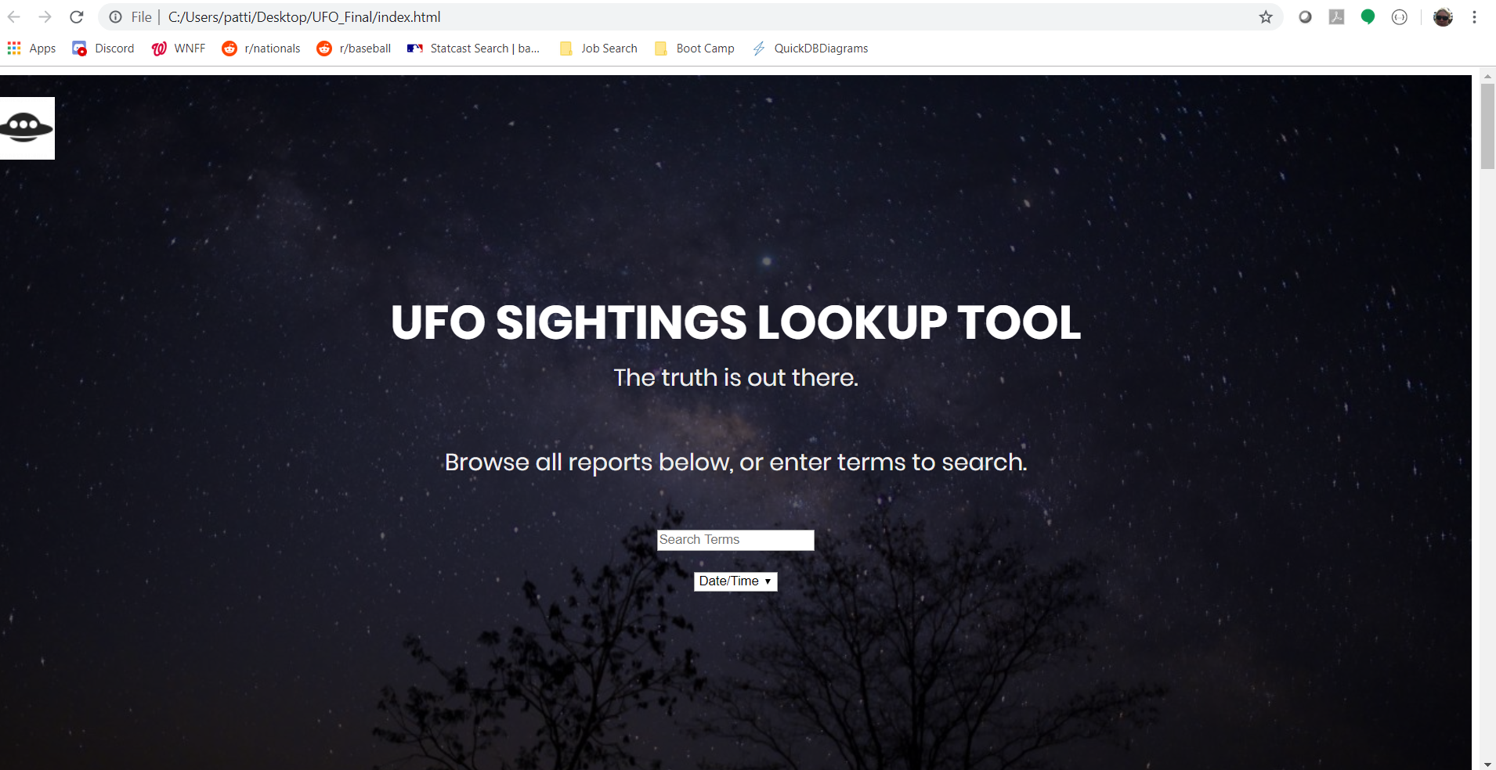

Search box drop down activates the selected column (only) as the search target.

Search box options:

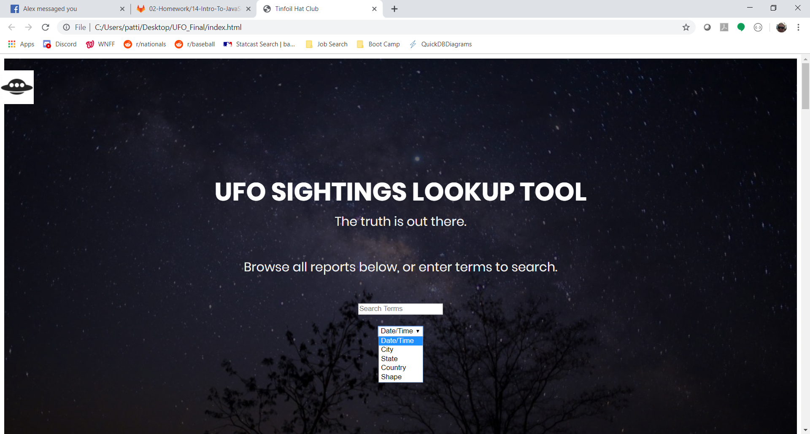

Smooth scrolling through entire table, with rows becoming active as the cursor moves over them:

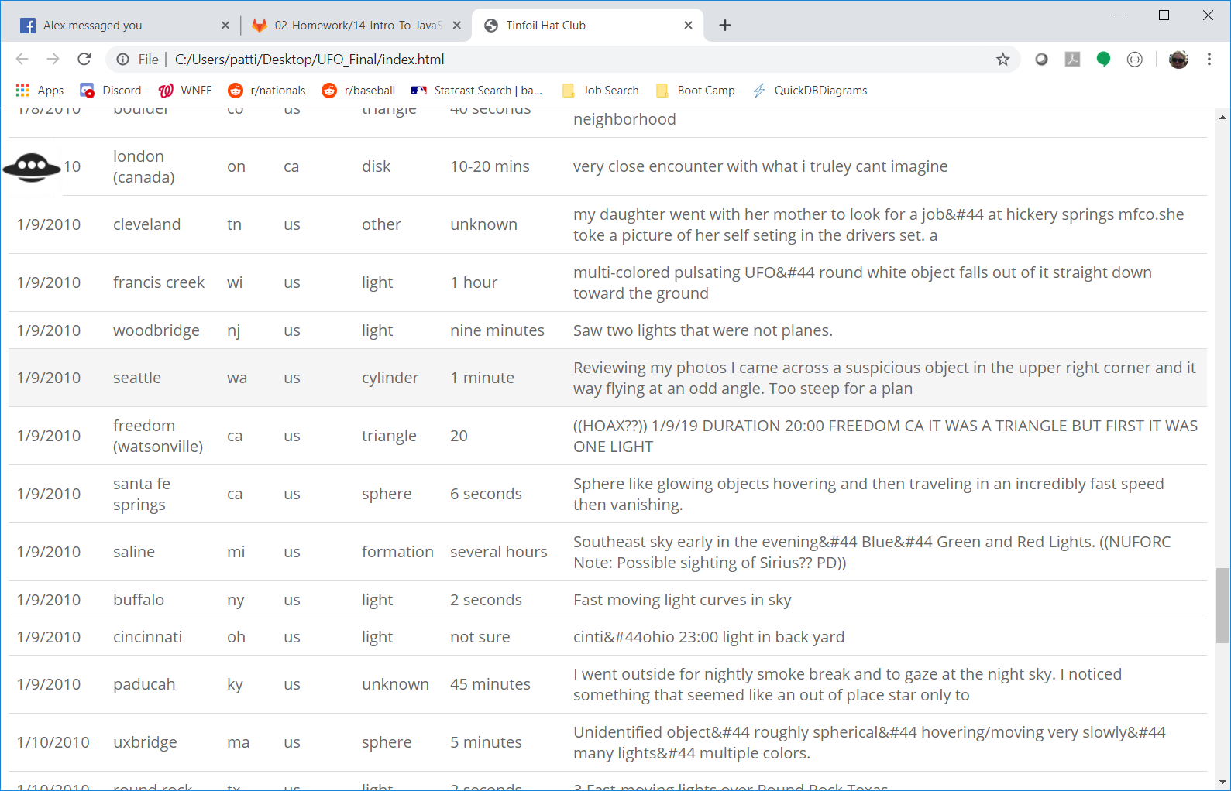

Table filters dynamically as terms are entered into the search box. Date/Time:

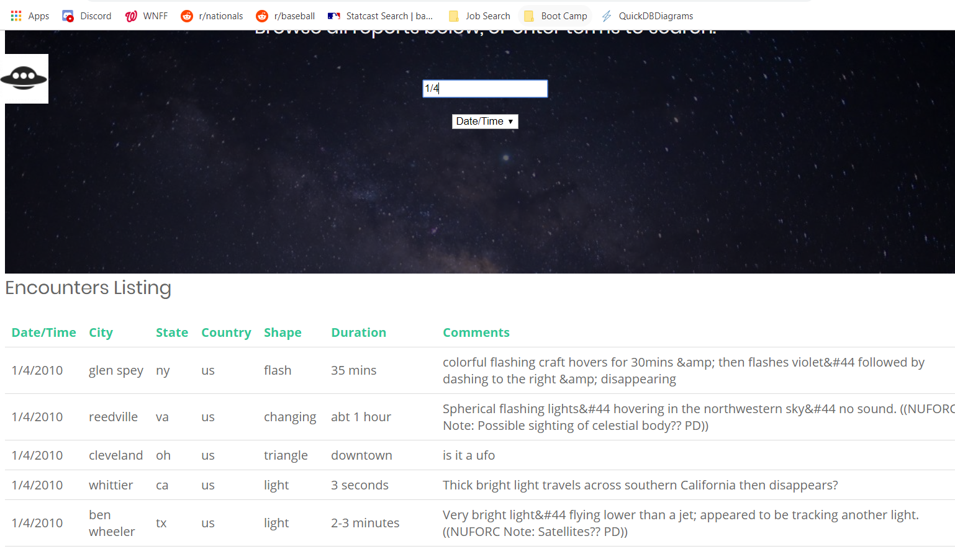

Searching within the Shape column:

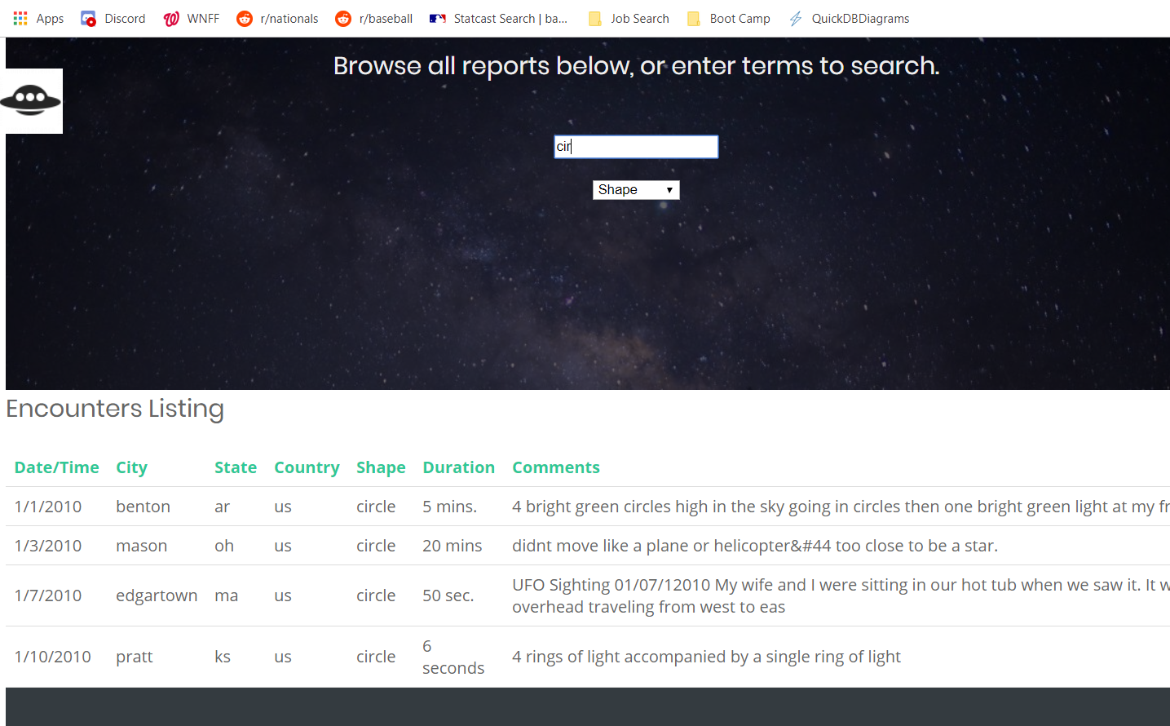

Columns are also sortable (examples: by Comments, and by City)

